Student’s Name
Instructor’s Name
Course
Date
The Past Apollo Program and the Future Mars Mission
The National Aeronautics and Space Administration (NASA) is an independent organization of the United States responsible for aerospace researches. Most United States space studies have been conducted by NASA, this includes the Apollo moon landing mission, Space shuttle, and the Skylab space station. NASA's mission focuses on exploring bodies throughout the solar system as well as researching astrophysics topics such as the big bang.
This essay documents the similarities and differences between the past Apollo moon landing mission and the future mission to Mars. The Apollo moon landing mission was the third the United States human spaceflight mission conducted by the National Aeronautics and Space Administration which succeeded in landing the first human on moon and returning him safely on earth. The Apollo program had the following goals, establishing a technology to meet other national interests on space, carrying out a scientific study of the moon and developing the human capacity to work on the lunar environment.
The planed future Mars mission addresses major scientific goals for the red planet. The mission will seek evidence of the habitable condition in the ancient past as well as a sign of past microbial life on the red planet. The mission will also gather technology that can address possible challenges likely to face future astronauts working on mars. This includes improving landing techniques, testing a method for producing oxygen from the mars atmosphere as well as identifying available resources such as subsurface water.
There are several similarities between the two National Aeronautics and Space Administration missions.one of the main objective of the Apollo program was to find the evidence of water on the moon. The Apollo astronauts collected samples of lunar rocks and brought them to earth for analysis. Traces of water were detected in the moon rocks. Similarly, the future mars mission will seek to find out the evidence of life in areas where liquid water was once stable and below the surface where it might exist today.
Besides, both NASA’s space missions are facing loud criticism over their cost. During the Apollo program, The United States Federal government spent $28 billons to land men in the moon between 1960 and 1963. several Americans criticized the government for spending more money in the space than on earth and argued that the funding should have been directed to other important programs. Similarly, the planned future Mars mission will cost the government $217.8 billion this includes the mars mission as well as operations in low earth orbits. Critics argue spaces missions are dangerous and the government should consider cutting down the budget because the immediate benefits of landing a human on mars are outweighed by the huge cost.
Extreme temperature and radiation threaten the lives of astronauts who venture into space. Specialized spacesuits were used to protect astronauts from harsh space conditions during the Apollo moon landing mission. These suits were made specifically for working on the lunar surface. similarly NASA is designing spacesuit with a similar structure to the Apollo astronauts but with different layers as they plan to send humans to Mars.
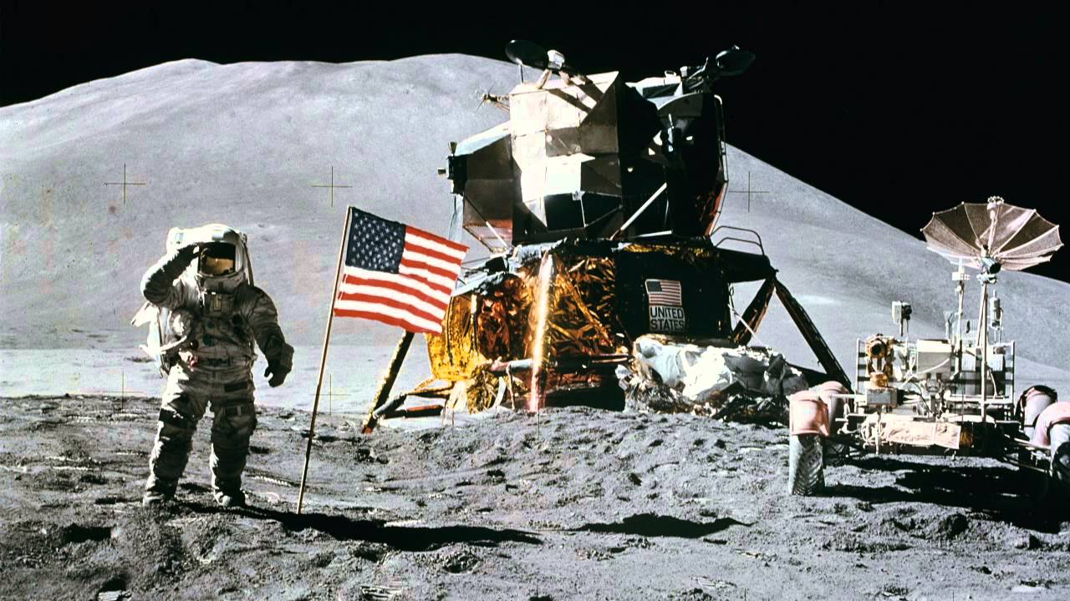
Neil Armstrong wearing the specialized spacesuits

The following are differences between the two NASA missions, during the Apollo moon landing mission all basic human essentials such as food and water were carried on the spaceships. However, in the planned future mars mission, astronauts will not carry their food and water on the spaceship due to long travel distance as well as an extended period of stay in mars. Currently, researchers are developing a device for feeding future astronauts.
A NASA official estimated future long-distance space crew will need up to forty different food processing machines to turn crops such as wheat and tomatoes into edible foods like bread and cereals,(Sparks, 124). However, food scientists at NASA are facing a problem of keeping space food equipment light, small and easy to maintain during the planned mars mission. Additionally, the Apollo moon landing mission took a few days whereas the future Mars mission will take years due to the long distance between planet Earth and Mars.
The planned mars mission is designed based on NASA's successful Mars science laboratory mission architecture including its proven landing system and curiosity rover, this is to keep the mission cost and risks as low as possible. The mission is timed for a launch opportunity in July when the earth and Mars are in a good position. This is because it takes less time and less power to travel to Mars in July compared to other times when the Earth and Mars are in different positions in the orbit. NASA scientists have also reported the planned future mars mission may involve great radiation risk. This is based on energetic particle radiation measured by RAD on the Mars science laboratory,(Vogt, 47). Astronauts involved in the mission are likely to face psychological problems due to long isolation from the earth.
Mars 2020 is the only future Mars mission under development; its spacecraft will use a guided entry, descent, and landing system. The mission landing system includes a parachute, a descent vehicle and sky crane maneuverer for lowering the rover on a tether during the final seconds of landing,(Hamilton, 237). This type of landing system provides a precise way of landing a large spacecraft on the surface of the red planet. The rover is equipped with technologies such as the Terrain relative navigation to allow the rover to detect and avoid hazardous terrain.it is also equipped with a microphone that allows engineers to analyze entry, descent, and landing. It can also capture the sound of the rover at work which provides engineers with a clue about its operations.
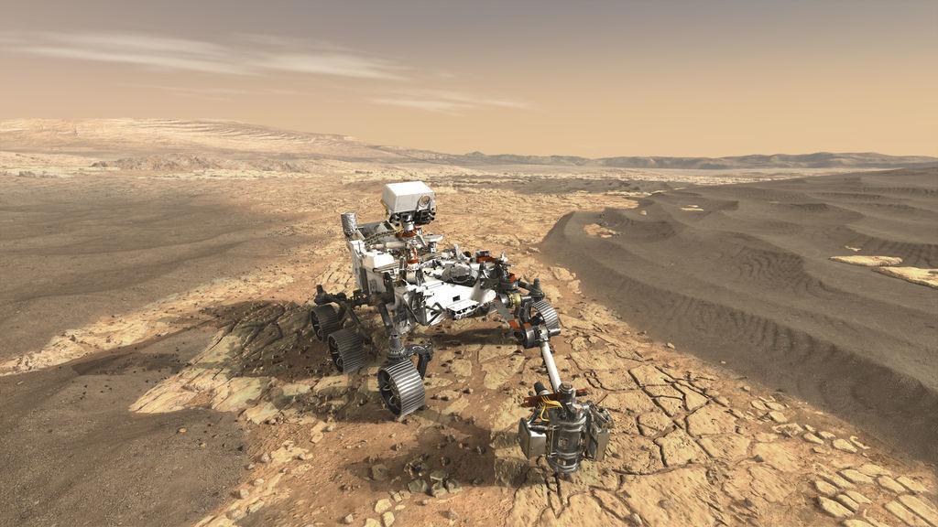
The mars 2020 spacecraft
The Apollo moon landing mission was launched by a Saturn V rocket from Kennedy space center. The spacecraft had three parts namely; a command module which hosted the cabin with the three astronauts, A service module which supported the command module with electric power, propulsion, water and oxygen and, a lunar module with two stages, that is a descent stage for landing on the moon and an ascent stage to place the astronauts back into the lunar orbit.
Over 650 million people watched televised images of Armstrong as he landed on the moon. Five Apollo spaceships landed on the moon safely but the Apollo 13 landing was prevented by an oxygen tank explosion in transit to the moon which destroyed their service module ability to provide electrical power crippling the command module propulsion and life support system. The crew returned to earth safely using the lunar module as a lifeboat for these functions (Hasday, 78). The Apollo mission set a major human spaceflight milestone.
In conclusion, there are several similarities and differences between the last Apollo moon landing mission and the future Mars mission. Both missions are based on technology and their main goal is to find out the existence of life outside our planet. Specialized spacesuits were used in the Apollo program to protect Astronauts from extreme space conditions. Astronauts in the future Mars mission will use food processing machines to cater to their hunger unlike in the Apollo moon landing mission were food and water were carried on the spaceship. Researchers conducted by NASA in the space will help us better understand the universe. Additionally, we were born explorers and if we stop exploring the universe we stop being humans.
Work Cited
Sparks, James C. Moon Landing, Project Apollo. Dodd, Mead, 1970.
Vogt, Gregory. Apollo And The Moon Landing. Millbrook Press, 1991.
Hasday, Judy L. The Apollo 13 Mission. Chelsea House Publishers, 2001.
Hamilton, John. Future Missions to Mars. Abdo & Daughters, 1998.

